Practical 4
Task 1:
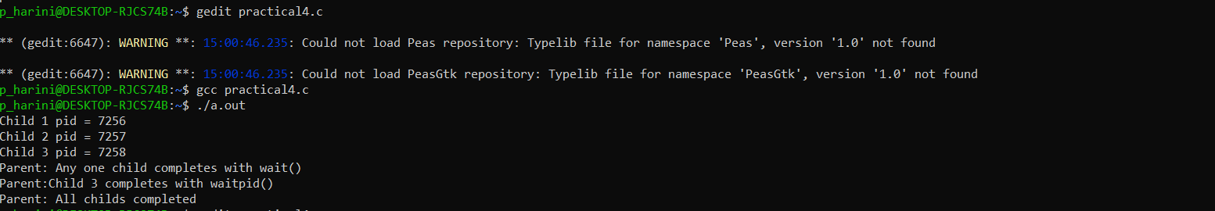

Task 2:
